

TECHNICAL REPORT TEMPLATE –
Temporary modifications to traffic signals for the purpose of roadworks and or events

INTERSECTION WORKS
STREET NAME - SUBURB
TRAFFIC MANAGEMENT PLAN DESIGNER
Contract XXXX
June 2019

 | Name / Company | Accreditation Details | Date | Signed
Report prepared by | XXXXXX | AWTM XXX | XX/XX/XX
Reviewed by | XXXXX | RTM XXXX | XX/XX/XX

Document No XXX-XXXXX | Rev. No. X | Date XX/XX/XX

Contents:

1 INTRODUCTION
  - Purpose and scope
  - Objectives
  - strategies

- PROJECT OVERVIEW
  - Location
  - Project Details, Site Assessment and Site Constraint /Impacts
  - Overview of potential Temporary Traffic Management arrangements

- TRAFFIC MANAGEMENT PLANNING AND ASSESSMENT
  - Traffic Assessment and Analysis
    - Traffic and Speed data
    - Traffic Flow Analysis
    - Current traffic signal phasing
    - Changes to traffic signal phasing
    - Changes to pavement marking
    - Software changes
    - Impact to adjoining network
    - End of queue treatment
    - Temporary Traffic Signals

  - Road Users
    - Pedestrians
    - Cyclists
    - Public Transport
    - Heavy and/or oversized vehicles
    - Existing Parking facilities
    - Access to adjoining properties / business
    - Rail Crossings
    - School crossings
    - Special events and other works
    - Emergency vehicle access

  - Night work provisions

  - Consultation and communication / notification
    - Other agencies
    - Public

  - TRAFFIC GUIDANCE SCHEMES

  - MODELLING RESULTS

3.7 MICROSIMULATION RESULTS

Introduction

1.1 Purpose and Scope
This technical report outlines the proposed temporary changes to traffic signals to be undertaken by the Project Manager to assist in effectively managing displaced traffic caused by the works/event.

Objective
The objective of the report is to ensure:

- The performance of the road network is not unduly impacted and the disruption and inconvenience to all road users are minimised for the duration of the works.
- Impacts on users of the road reserve and adjacent properties and facilities are minimised.
- The proposed temporary modifications to traffic signals are appropriate prior to commencement.
- Demonstrate that the TMP designer has conducted a thorough analysis of potential various temporary traffic management treatments.
- Demonstrate that various construction methodologies have been explored to expedite completion of the works.

Strategies
In an effort to meet these objectives this report will incorporate the following strategies:

<Amend if required based on the project>
- Providing a sufficient number of traffic lanes to accommodate vehicle volumes.
- Ensuring delays are minimised.
- Ensuring all road users are managed including motorists, pedestrians, cyclists, people with disabilities and people using public transport.
- Ensuring work activities are carried out sequentially to minimise adverse impacts.
- Provision will be made for works personnel to enter the work area in a safe manner in accordance with safety procedures.
- All entry and exit movements to and from traffic streams shall be in accordance with the requirements of safe working practices.

Project overview

Location
Insert Sketch

Figure 1 Site Location

SCATS DRAWING

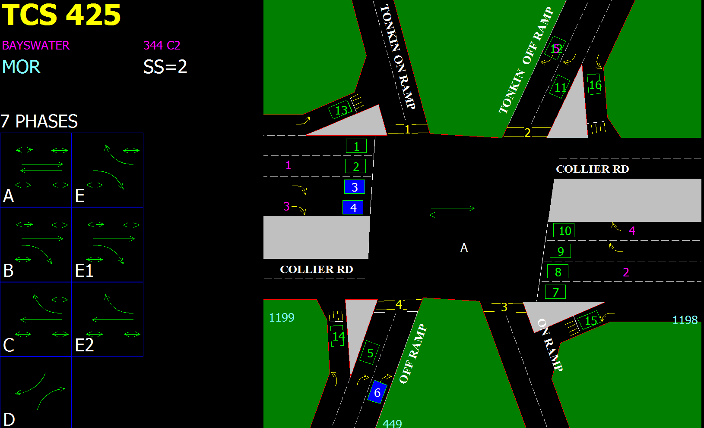

Example above: Intersection Collier Rd at Tonkin Highway

Project Details, Site Assessment and Site Constraint / Impacts
ITEM | DESCRIPTION
Project
Location

Road Classification, Existing Speed Limit
Road Authority
Local Government
Client
Prime Contractor
Sub-Contractor
Contractor undertaking signal modification | (Include company name and contact details)

Overview of Potential Temporary Traffic Management Arrangements
ITEM | DESCRIPTION
Temporary Traffic Management Descriptions
Speed zone dates and times
Lane Closures dates and times
Road Closures dates and times
Signal modifications description
Proposed lane widths

Road Safety Barrier

Traffic Management Planning and Assessment

Traffic Assessment and Analysis

Traffic and Speed Data
A summary of recent traffic data is provided below:

Location | Vehicles per day (% heavy vehicles) | Date | Source
[ROAD NAME] (Site Number) | [NUMBER] ( %) | [DATE] | [Traffic Map]

A summary of recent speed data is provided below:

Location | Posted Speed (km/h) | 85th Percentile Speed (km/h) | Date | Source
[ROAD NAME] (Site Number) | [NUMBER] | [NUMBER] | [DATE] | [Traffic Map]

Traffic Flow Analysis
Should include an analysis and commentary of the following:

- Traffic volume and composition against minimum lane requirements (should include traffic modelling data if requested by Main Roads).
- Traffic management selected - lane closures, road closures, speed reductions, detours, single lane reversible flow, side tracks etc.
- Dates, times and locations of proposed traffic management.
- Additional methods in place to minimise impacts to road users

Current Traffic Signal Phasing
<Amend as required>

TCS 123 currently operates as a split phase

Changes to Signal Phasing
<Provide analysis and commentary of any required lane closures and/or signal modifications required at permanent traffic signals>

Changes to Pavement Marking

Software Changes

Impact to Adjoining Network
<Provide analysis and commentary of expected impact on the adjoining road network. Include any consultation with other road agencies>

End of Queue Treatment
<If using traffic control provide analysis and commentary of predicted queue lengths and treatments (see Main Roads Fact Sheet Traffic Control - Avoiding End of Queue Collisions on High Speed Roads >

Temporary Traffic Signals
<Note as N/A if not using traffic signals>
In the event that portable or temporary traffic signal fail to operate correctly, Traffic Controllers shall be deployed immediately to control traffic movements.

Road Users

Pedestrians
<If pedestrians will be impacted provide details on how pedestrians, including pedestrians with disabilities, will be safely managed>

Cyclists
<If cyclists will be impacted provide details on how they will be safely managed>.

Public Transport
< If public transport facilities will be impacted provide details on how this will be managed, include
any consultation and/or approval from the Public Transport Authority (PTA)>

Heavy and Oversized Vehicles
<If heavy and/or oversized vehicles will be impacted provide details on they will be catered for (consider lane widths and swept paths)>

Existing Parking Facilities
<If parking facilities are within the work site provide details on how this will be managed>

Access to Adjoining Properties / Business
<If properties or business will be impacted provide details on how this will be managed>

Rail Crossings
<If rail crossings will be impacted provide details on how this will be managed>

School Crossings
<If school crossings will be impacted provide details on how this will be managed>

Special Events and Other Works
<If there are any special events or concurrent works provide details on how this will be managed>

Emergency Vehicle Access
<For works involving traffic controllers or road closures provide details on allowing emergency vehicle access through or past the worksite>

Night Work Provisions

Consultation and Communication / Notification

Other Agencies
<Detail consultation/communication with relevant agencies as required, e.g. PTA, Emergency Services, Local Government Agencies, Main Roads Heavy Vehicle Services, etc>

Public
<Amend as required>

The public shall be notified of the works and traffic management arrangements which will affect journey times via:

- Notice to Motorists in the weekend West Australian newspaper placed two weeks in advance of the scheduled works;
- Letter drop to all residents and businesses within the traffic control zone one week ahead of the scheduled works; and,
- VMS boards during the works.

Traffic Guidance Schemes
The TGS outlined in Appendix 4 and listed below have been provided for the following stages to demonstrate the type of controls that will be implemented throughout the term of the contract. All sign and device requirements are shown on each TGS. Should the use of additional (not shown on the TGS or listing of devices) or reduced number of devices be required due to unforeseen needs, they will be recorded within the Daily Diary as a variation to the TMP, following prior approval.

Construction Stages | Traffic Management Stages | LMA Number and version | TGS Number and version | Details  <Include work description, temporary traffic management arrangements, times of day in place, and any other required information>
Stage 1 | 1.1 |  |  | Increasing the green time for phase C to maximise the clearing capacity for the right turn movement, in order to accommodate the existing right turn demand and the additional detoured traffic.
Stage 1 | 1.2 |  |  | Provide a leading right turn green arrow for motorists on XX Street so that general traffic can turn right into XX Street unopposed.
Stage 1 | 1.3 |  |  | Install a pedestrian detour at the intersection to prevent path users from crossing at an unprotected crossing. A Traffic Controller shall be onsite to assist path users as required.
Stage 2 | 2.1 |  |  | Provide a leading right turn green arrow for motorists on XX Street heading westbound so that buses can turn right onto XX Street unopposed.
Stage 2 | 2.2 |  |  | Line mark the current shared through/ right lane at the southern approach of the intersection to a ‘right only’ lane, with temporary delineation to direct all northbound traffic on XX Street to enter the kerb side lane on the approach to the XX Street intersection This modification will prevent motorists intending to travel straight ahead becoming trapped behind a right turning motorist at the intersection.

MODELLING RESULTS

<The following outputs should be included in the traffic model. Calculations should be based upon the current operation of the intersection (and/or surrounding intersections) versus the expected performance under temporary traffic management arrangements. Main Roads may request additional modelling outputs as required. >

LinSig Model Outputs
Item | Lane Description | Total Green (s) | Demand Flow (pcu) | Sat Flow (pcu/Hr) | Capacity (pcu) | Deg Sat (%) | Total Delay (pcuHr) | Av. Delay Per PCU (s/pcu) | Mean Max Queue (pcu)
Network: E.G Hay Street Bridge Modifications | - | - | - | - | - | % | - | - | -
E.G Mitchell Fwy Ramps / Hay Street | - | - | - | - | - | % | - | - | -
1/2+1/1 | - | - | - | - | - | - | - | - | -
1/3+1/4 | - | - | - | - | - | - | - | - | -
2/1 | - | - | - | - | - | - | - | - | -
2/2 | - | - | - | - | - | - | - | - | -
2/3+2/4 | - | - | - | - | - | - | - | - | -
3/2+3/1 | - | - | - | - | - | - | - | - | -
3/3 | - | - | - | - | - | - | - | - | -
4/1 | - | - | - | - | - | - | - | - | -
4/2 | - | - | - | - | - | - | - | - | -

Comparison table
Criteria | Approach Name | Existing (2019) | Proposed TMP | Existing (2019) | Proposed TMP
Criteria | Approach Name | AM | AM | PM | PM
Cycle time (s)
Phase Sequence
Level of Service
Av. Delay per PCU(s/pcu)
Worst Deg. Of Sat (%) N
Worst Deg. Of Sat (%) S
Worst Deg. Of Sat (%) E
Worst Deg. Of Sat (%) W
Worst Deg Of Sat (%)
Worst MMQ (pcu's)
Worst Approach

Microsimulation Results

Intersection Performance Output
Scenario (e.g existing AM Peak)
Location | Approach | Direction | Volume (veh/hr) | Delay (sec) | LOS | Avg Queue length (m)
 | North | Left-turn
 | North | Thru
 | North | Right-turn
 | East | Left-turn
 | East | Thru
 | East | Right-turn
 | South | Left-turn
 | South | Thru
 | South | Right-turn
 | West | Left-turn
 | West | Thru
 | West | Right-turn

Network Performance Outputs
Scenario (e.g existing AM Peak)
Number of vehicle served
Average speed (km/h)
Average delay per vehicle (s)
Total latent traffic demand

END OF DOCUMENT

